39.69: Time of flight of the marble, from free-fall kinematic equation is just 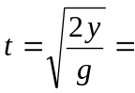
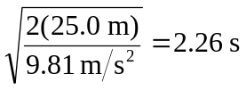
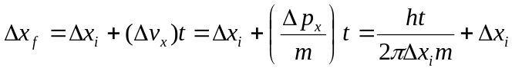
to minimize 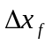with respect to 